FINAL PROJECT REPORT

Project Title: Fine-Tuning a Large Language Model for Summarization and Conversion to GGUF Format.

The goal of this project was to apply supervised fine-tuning on a pre trained large language model so that it performs the specific task of text summarization to generate concise, high-quality summaries across diverse content types.
The model was named as LaserPoint.

Training Dataset:
- The dataset used for training the model for the task was stored in a .jsonl file (processed_file.jsonl).
- The file was prepared after merging data from multiple csv files into one and then finally converting it into .jsonl file.
- The coding environment spyder was utilized for the conversion and its cleaning.
- The dataset consists of 20,358 samples as long text and summary.
- The data used include:- CNN / Daily Mail articles, Reddit conversational data.
- The preprocessing of the dataset before passing it to the model was done in Google Colab.
Resources Used:
- Base Model: Mistral-7B-Instruct-v0.1
- Fine-Tuning Technique: LoRA (Low-Rank Adaptation)
- Quantization: 4-bit (NF4) using bitsandbytes
- Frameworks: Hugging Face Transformers, PEFT, Datasets, Accelerate
- Training Platform: Google Colab
- Deployment: llama.cpp (GGUF Runtime)
- Storage: Google Drive and Local File System

Coding Snapshots and Explanations:
Importing Required Libraries and Loading Model using 4-bit Quantization
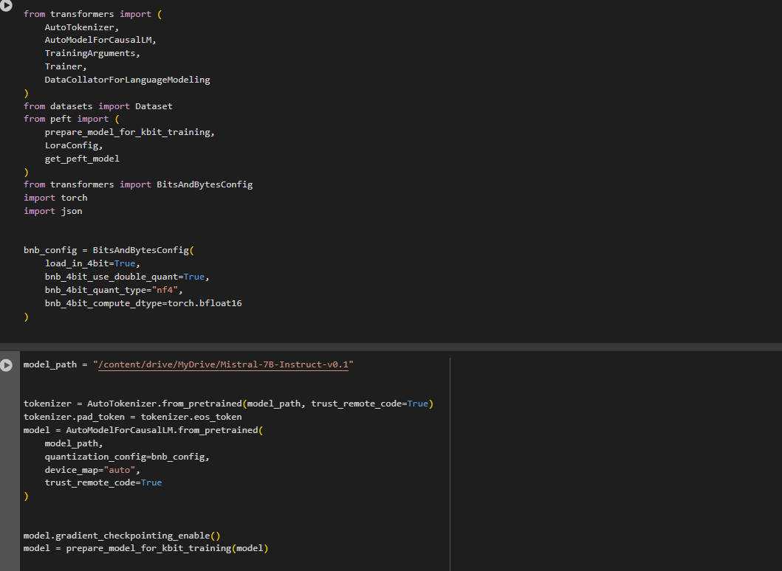
The necessary libraries were imported. The transformers library handles tokenization, model loading, training configuration and data collation. The datasets library handled working with custom dataset and peft tools were imported to apply LoRA to the model. BitsAndBytesConfig was used to set up 4-bit quantization. The configuration was created to load the model in 4-bit mode which saved memory and made the training faster. After that tokenizer was loaded to split text into tokens. Actual model was loaded using the path where it was stored and 4-bit settings was applied. The model was then prepared for LoRA training.

Training
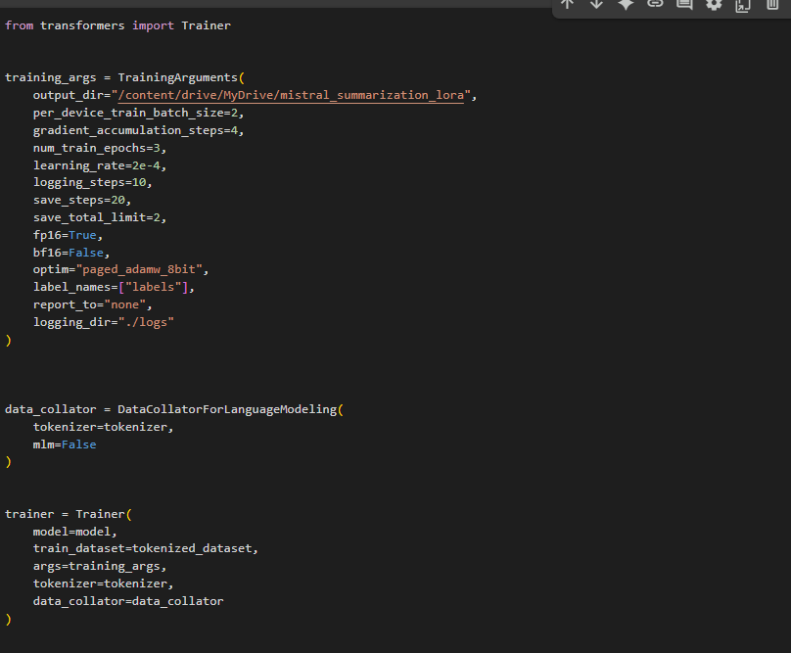

The Trainer class was used to set up the training process. TrainingArguments was defined which includes:- where to save the model, how many training steps to run, how often to save progress, and the learning rate. Data_collator helps to format the input data during training. The Trainer object was created and passed the model, tokenized training data, training arguments, and data collator. This object handles the entire training process. The training had 7635 steps which took 36 hours to complete.

GGUF Conversion
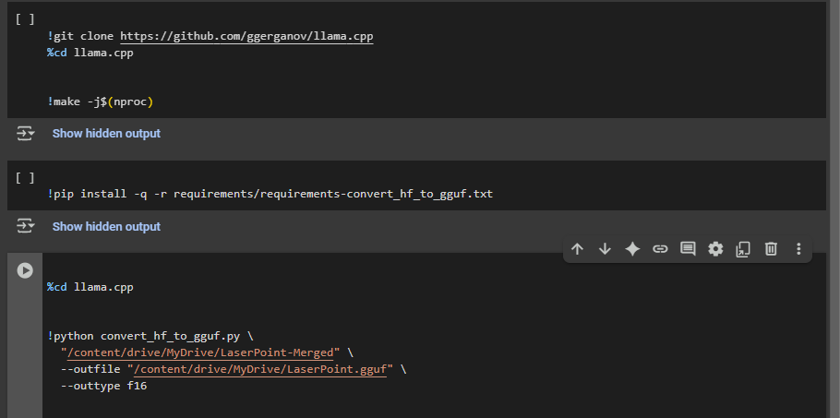

The llama.cpp GitHub repository was cloned, which contained tools to convert and run LLMs locally. Then it was compiled using make command. The required dependencies were installed using a requirements file provided by the repository. The python script convert_hf_to_gguf.py was used to convert the model into a .gguf file and then the output file LaserPoint.gguf was saved to Google Drive.
Output:
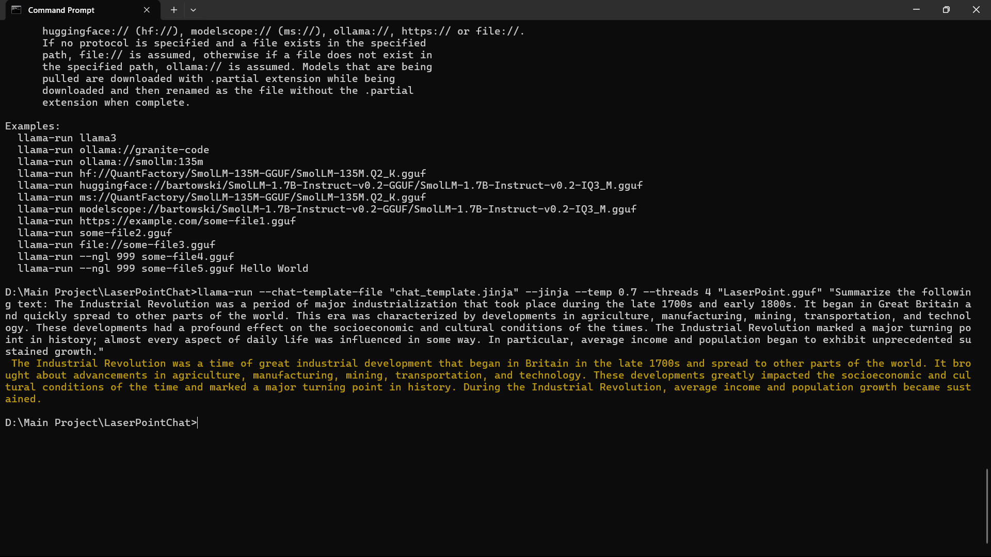

After training and successful conversion of the model into GGUF format, it was deployed locally using llama.cpp. It was executed in command prompt. A long prompt related to industrial revolution was used for summarization. The model generated an informative summary which included important aspects of the lengthy input. This confirmed that the summarization logic and fine-tuning were successful.

Conclusion:
LaserPoint successfully summarizes large input texts in an accurate manner. The model functioned properly on a local machine without any further issues. The model can be trained on scientific and medical texts for further improvement.

